## POI7, POI8

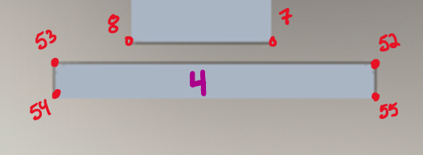

Both of these pulled a point from edge that was manually placed between 52 and 53. This makes more sense than 52 or 53.

## POI 16

